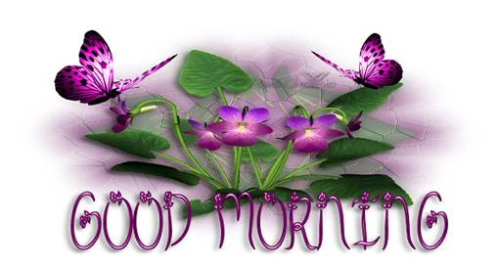
金 錢
Verily I say unto ye ... M O N E Y

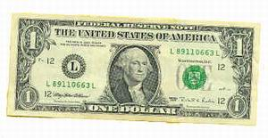

可以買到房子
It can buy a house

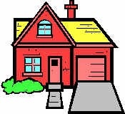

但買不到一個家
But not a home

可以買到時鐘
It can buy a clock

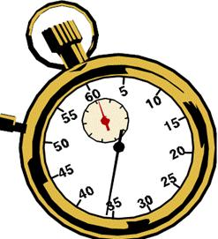

但買不回寶貴光陰
But not time

可以買到地位
It can buy you a position

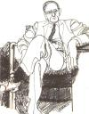

但買不到別人的尊重
But not respect

可以買到床褥
It can buy you a bed

但買不到充足睡眠
But not sleep

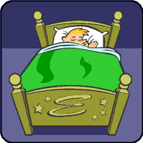

可以買到書本
It can buy you a book
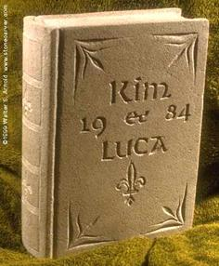

但買不到知識
But not knowledge

可以買到藥物
It can buy you medicine

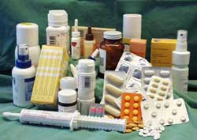

但買不到健康
But not health

可以買到血液
It can buy you blood
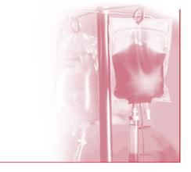

但換不到生命
But not life

金錢非萬能，卻經常帶給你痛苦煩憂
So you see money isn't everything
And it often causes pain and suffering
你是我的好朋友，我不忍心見你受苦
I tell you this because I am your friend
And as your friend I want to
Take away your pain and suffering!!
把所有的金錢都給了我，我會代你擔當一切
So send me all your money
And I will suffer for you!
友情何價？？

CASH ONLY PLEASE !!!
After all, what are friends for, huh??

希望這話會令你發笑，笑是最佳良藥！
I HOPE THIS MADE YOU SMILE!!!
LAUGHTER IS THE BEST MEDICINE!
MONEY CAN'T BUY GOOFY E-MAILS, EITHER!!
THEY COME FROM YOUR CRAZY FRIENDS!
錢買不到這般妙語，唯有老友記才會轉告你！

